6A^{th} Grade: Unit 6, Lesson 12

- What value will make both equations true?
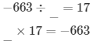

-39

- What is the value of the expression $-2×(-1)×5×(-3)×(-1)$?

30

- What number, when multiplied by -2, would result in a product of -28?

14

